**SQL Tutorial**

Use this [site](http://www.w3schools.com/sql/trysql.asp?filename=trysql_select_all) (please use Chrome Browser) to write your SQL queries and fill in your final answer below each question). The answers are in the compressed zip file. The password is the last 3 EmployeeIDs of the last question’s answer (without spaces or quotes) e.g. “8410”.

1. Display a list of all employees sorted according to Last Name in ascending order i.e. A-Z.

SELECT * FROM Customers

ORDER BY CustomerName Asc

**Note: SUBSTRING function not working on site to extract LastName**

2. Display a list of all suppliers from France who but not from Paris.

SELECT * FROM Suppliers

WHERE Country = 'France' AND Country NOT LIKE '%Paris%';

**Note: Paris already is not in the result data set**

3. Display all Suppliers whose SupplierName name begins with N.

SELECT * FROM Suppliers

WHERE SupplierName LIKE 'N%';

4. Display a list of each country where customers are located (N.B. Your list should not contain two of the same values).

SELECT DISTINCT (Country) FROM Customers;

5. Display a list of all Customers and their order dates that made orders after 1996. Your result should look as follows:

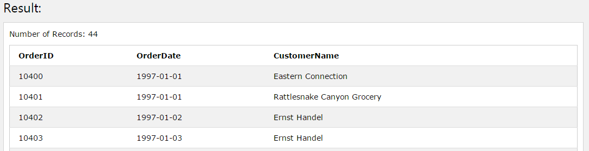

SELECT o.OrderID, o.OrderDate, c.CustomerName

FROM Customers c, Orders o

WHERE o.OrderDate > '1996-12-31' AND o.CustomerID = c.CustomerID;

6. Display each Order and Product ID sold as well as the total sales for each product (sales = productprice*quantity). Hint: You will have to join the Products table to get the price of each product. Your result should look as follows…

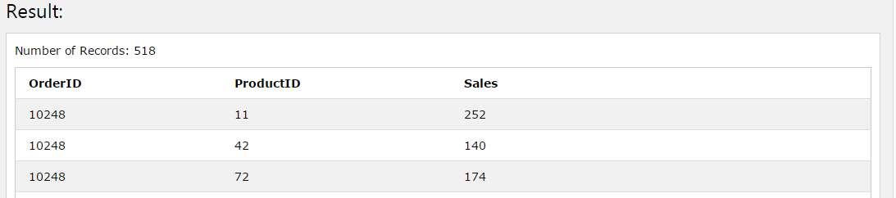

SELECT od.OrderID , od.Quantity, p.Price * od.Quantity

FROM Orders o, OrderDetails od, Products p

WHERE o.OrderID = od.OrderID AND p.ProductID = od.ProductID;

7. Edit your previous query to display the Total Sales for each order. Note that orders may contain multiple products sold however we want to display the sum of all the sales for each order. Your result should look as follows…

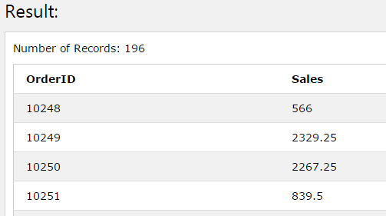

SELECT od.OrderID , od.Quantity, SUM(p.Price * od.Quantity) AS Sales

FROM Orders o, OrderDetails od, Products p

WHERE o.OrderID = od.OrderID AND p.ProductID = od.ProductID

GROUP BY od.OrderID;

8. Edit your previous query to display all Order ID's as well as their Total Sales where the Total Sales for the whole order is greater than 10000.

SELECT od.OrderID , od.Quantity, SUM(p.Price * od.Quantity) AS Sales

FROM Orders o, OrderDetails od, Products p

WHERE o.OrderID = od.OrderID AND p.ProductID = od.ProductID

GROUP BY od.OrderID

HAVING Sales > 1000;

9. Select all order IDs that sold Products with IDs 19 and 35 on the same order i.e. for each order listed, it needs to contain product ID 19 and product ID 35. N.B we’re just looking for the OrderID to be returned. HINT: You can use a sub-query within your query.

???

10. Write a query to list all Employees as well as how many orders they have sold even if they have not made any orders and order the result by number of orders. Your list should like the below diagram…

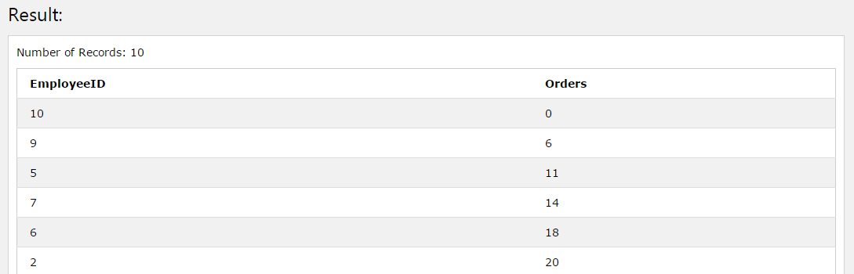

SELECT e.EmployeeID, COUNT(o.OrderID) As Orders

FROM Employees e, Orders o

WHERE e.EmployeeID = o.EmployeeID

GROUP BY e.EmployeeID

HAVING Orders >= 0

ORDER BY Orders ASC